From the experimental data.

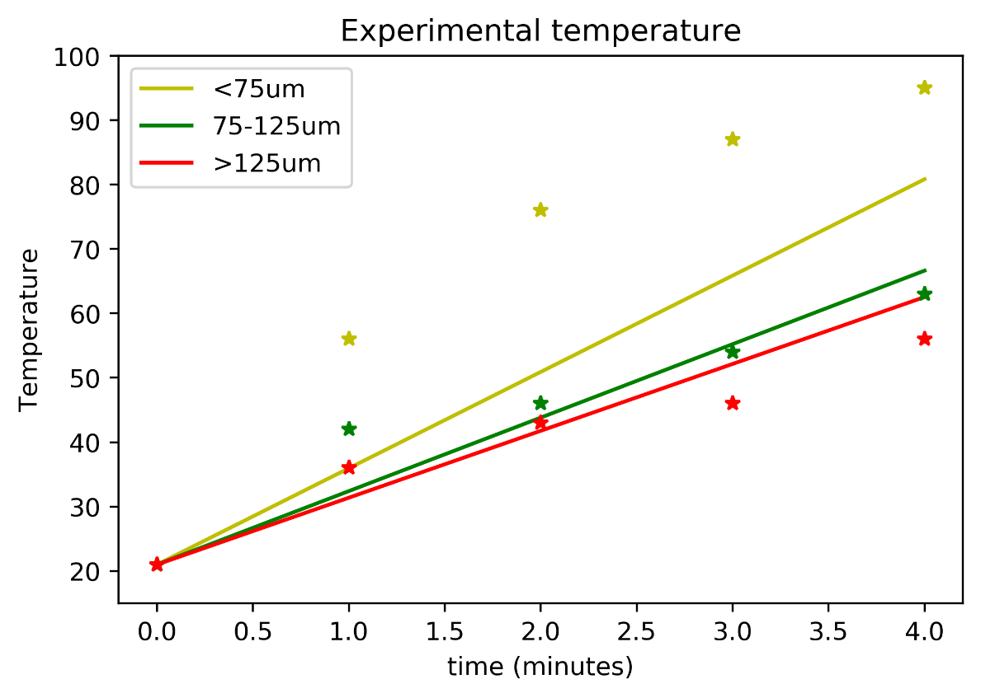

Linear temperature result based on simulation.

ODE setup:

T

TAmbient

TAmbient

Thus, the equation for the dT/dt is:

$$\frac{dT}{dt}=\frac{2πf}{C_{P}ρ}εε''E^{2} +\frac{λ}{C_{P}ρ}\frac{δ^{2}T}{δx^{2}}$$

Assume $ρ=ρ_{specific}k$ where k is the fill factor, and $ρ_{specific}$ is the specific particle density. The equation above becomes:

$$\frac{dT}{dt}=\frac{2πf}{C_{P}ρ_{specific} }\frac{1}{k}εε''E^{2} +\frac{λ}{C_{P}ρ_{specific} }\frac{1}{k}\frac{δ^{2}T}{δx^{2}}$$

Assume $c_{1}= \frac{2πf}{C_{P}ρ_{specific} }$ and $c_{2}= \frac{λ}{C_{P}ρ_{specific} }$, then the equation becomes

$$\frac{dT}{dt}=c_{1}\frac{1}{k}εε''E^{2} +c_{2}\frac{1}{k}\frac{δ^{2}T}{δx^{2}}$$

$$\frac{dT}{dt}=c_{1}\frac{1}{k}εε''E^{2} +c_{2}\frac{1}{k}(2T-2*T_{Ambient})$$

Using finite difference scheme, the equation is solvable.

When c1 increase, the graph becomes more linear as the heating rate increases.

As c2 increases, the graph tends to plateau at high temperature.

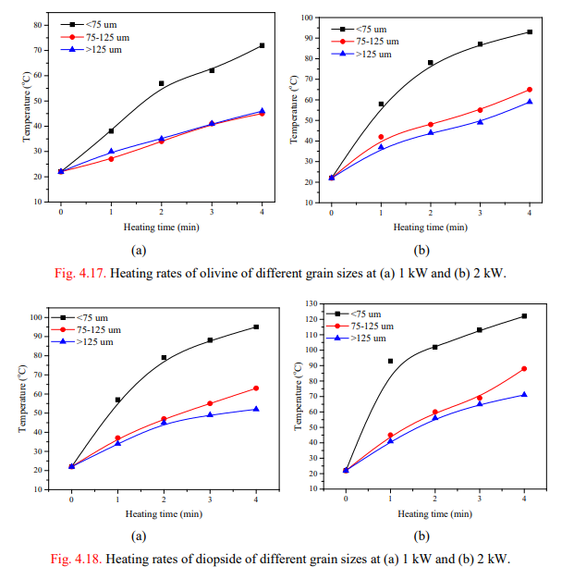

We can fix 1 constrain and 1 optimization parameter based on the experimental data.

Constrain: temperature reach at the end of experiment is fixed.

Optimization parameter: the resulting curve shape from c1 and c2 should have minimal mean squared error from the experimental data.

Through this, c1 and c2 can be calculated.

Assume c1 and c2 is approximately the same across different experiments. When the c2 is known through averaging c2 between different experiments, c1 can be calculated based on simulated E2 field.

Since c1 and c2 is known, the simulated temperature plot can be created.

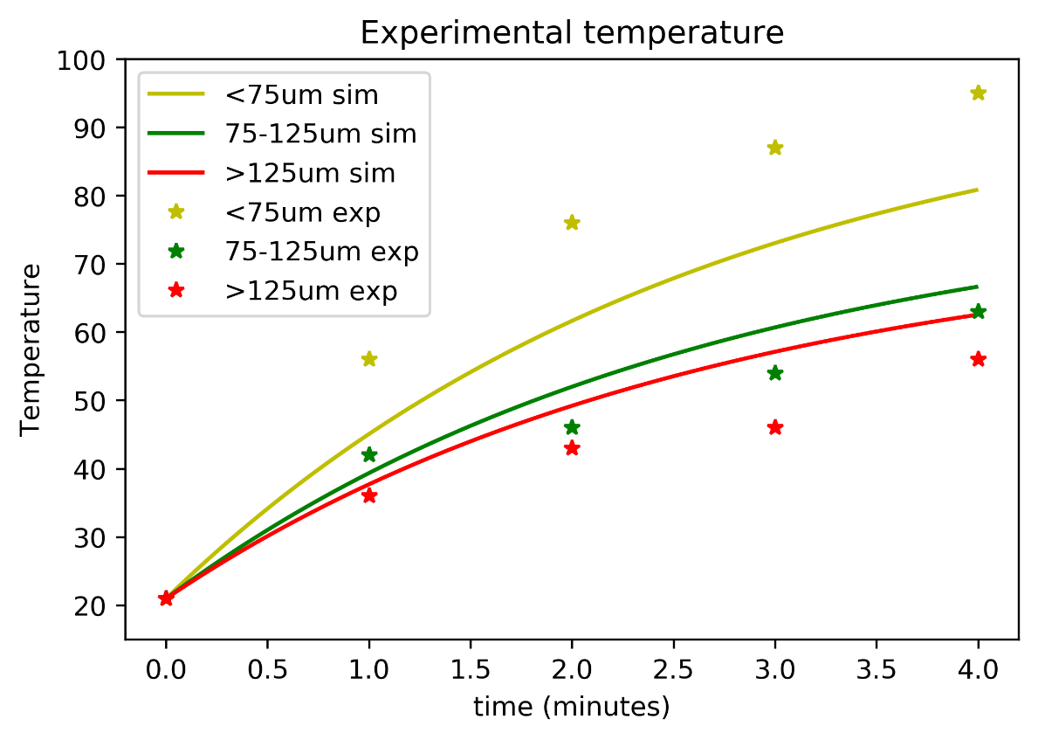

Through this calculation, I was able to get more accurate coefficient.